The questionnaire was answered by 140 pupils at the age of 10 to 14. We have noted the most frequent answers:
- What do you think, what is peace?

When people do not hurt each other
When there are not any wars
When people help each other
When people do not fight
When people are friendly and kind
When people make friends

- Are you afraid of strangers?

Yes 0% No 64% Sometimes 36%
Why?
No: We are the same but we speak different languages
Sometimes: Strange people can sometimes harm children, they sometimes look different
and I am sometimes afraid when I do not know them
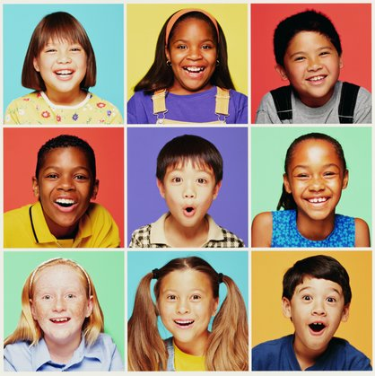
- Are the people of other nationality or other colour of skin (Afro-Americans, Chineses, Russians, Romans,e.t.c.) as good as you and other Slovaks?

Yes X
No 
Why?
Everywhere there are good and bad people, they are the same as we are, but they can have different colour of skin and speak different languages.

- What would you do if to your class come to learn a student from another country?

Afraid to initiate conversation 0%
Try to make friends 51%
Tell about Slovakia and Slovaks 17%
Would like to know about his/her country 32%
He/she doesn’t interested me 0%

- What would you like to learn more from your foreign friend? Tick 3 notes that you are interested in more !
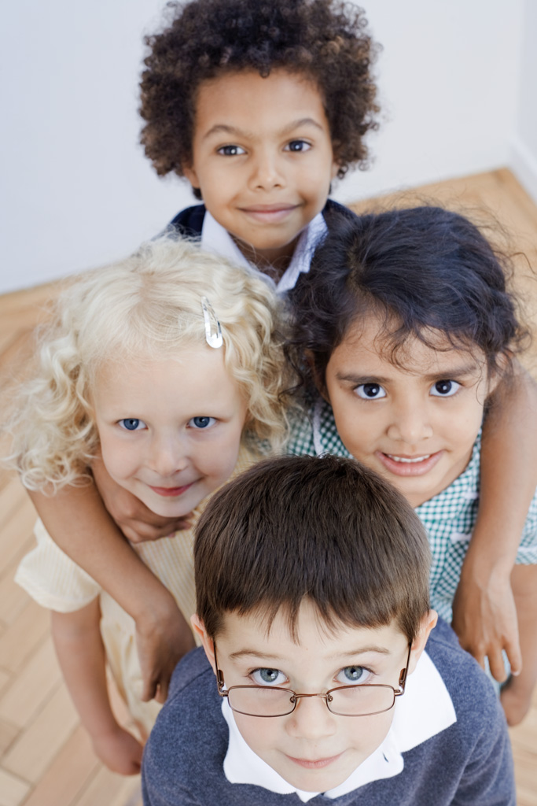
For them:
0% Songs
0% Dances
49% Clothes
15% Food, dishes
11% Traditions, customs,rituals
25% Architecture(buildings)

Write anything else what are you interested in!
Sports, games, schools, housing, harbours, lifestyle.

6.Let’s think two groups of people from different countries come together. In the first group there are children from different countries and in the second one there are adults from different countries. Which group would become friends easier? Why?
100% CHILDREN

Because children are the same everywhere, they are more communicative, they like playing
games, they are not as ashamed as adults.

7.What do you think, what are the similarities between you and foreigners?
We are human beeings
Personalities, emotions, laws, lifestyle, hobbies, ideas, meals
Everybody wants to be happy

Thanks four your job!

